1. The Protocols present in the protocol column in the unfiltered packet-listing window are DNS, HTTP, TCP, ICMPV6, LLMNR, OCSP, and NBNS. Please find the screenshots attached below.

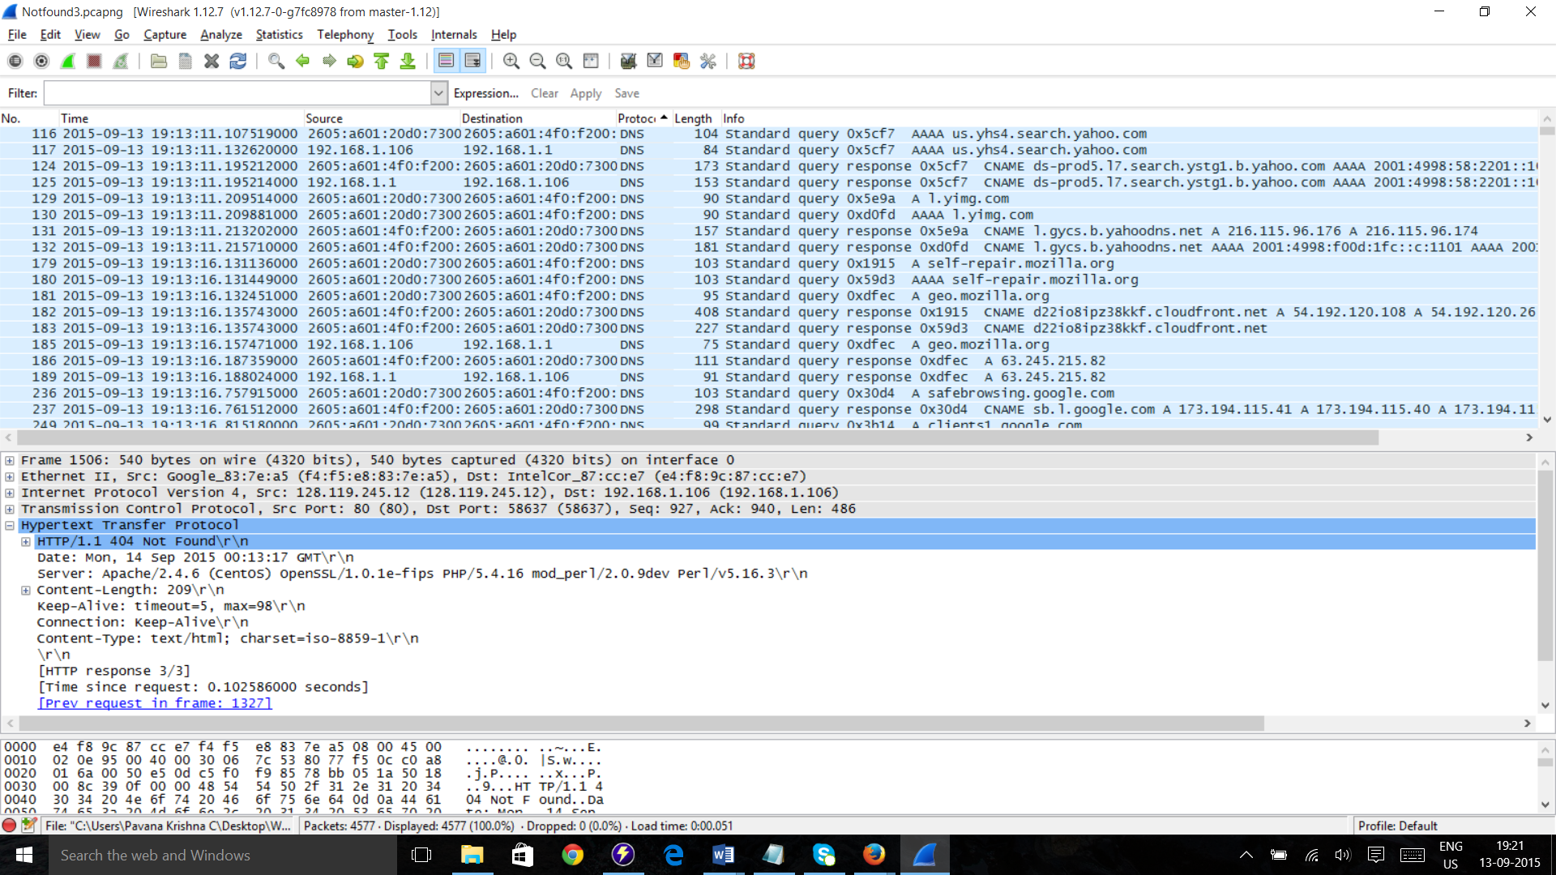

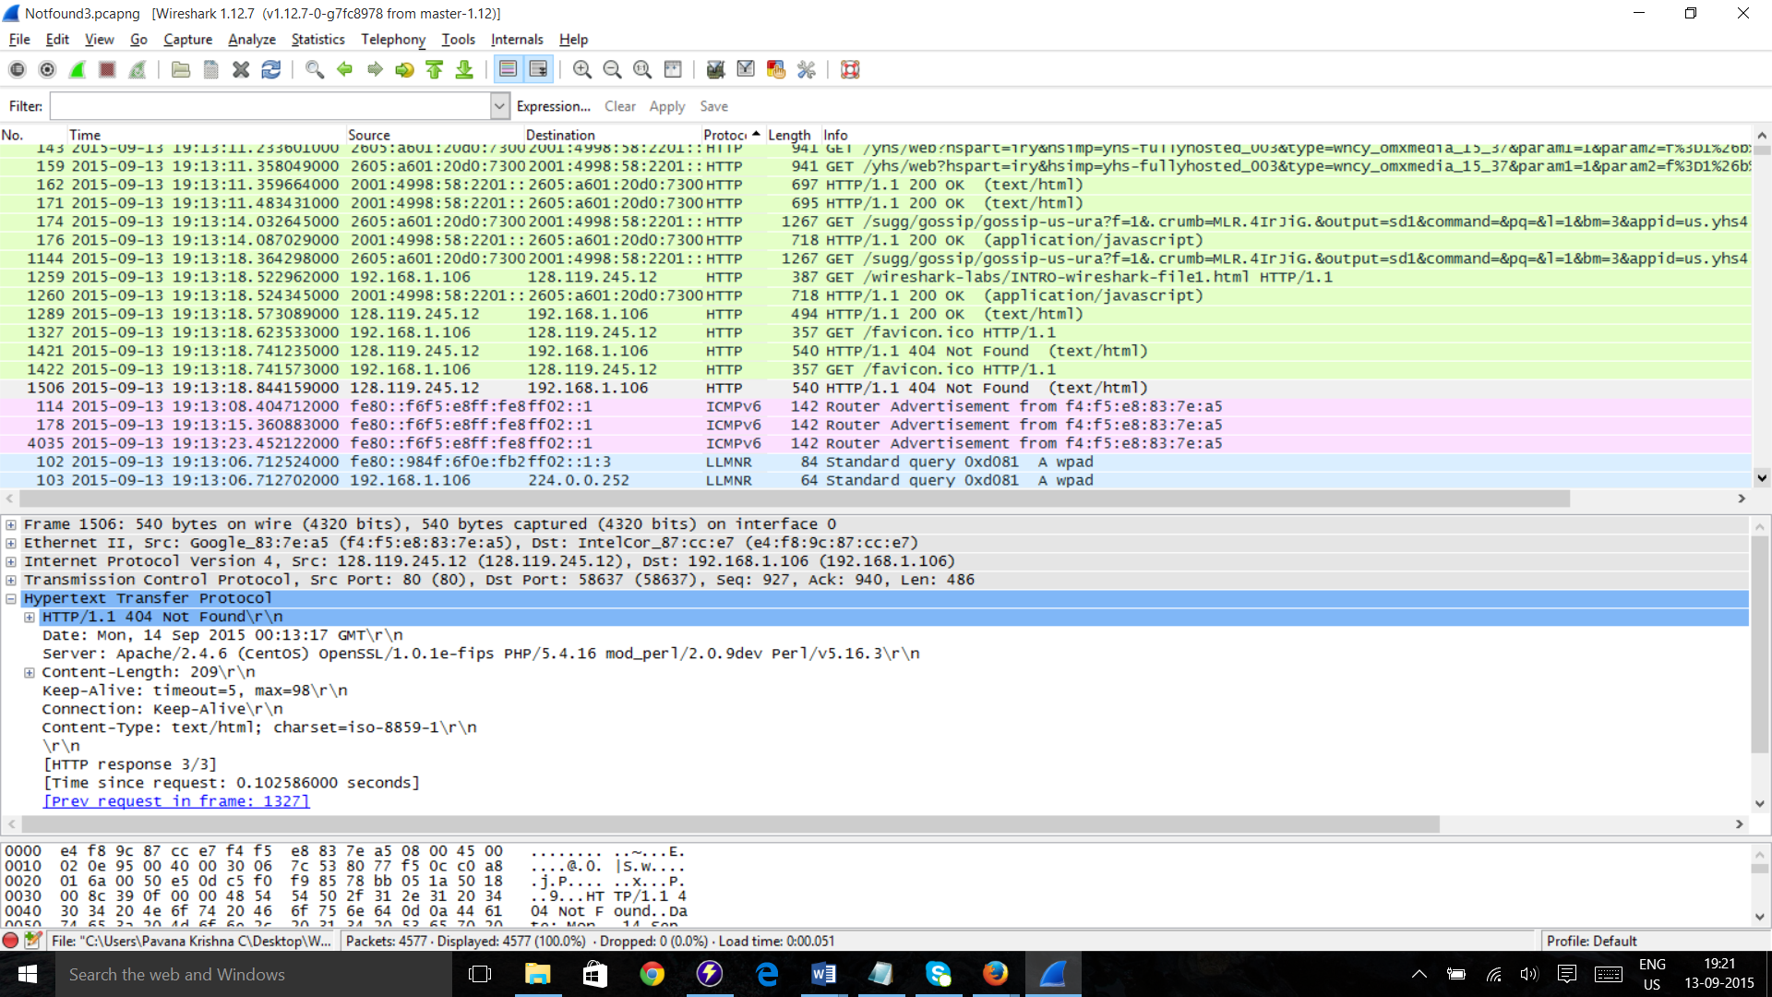

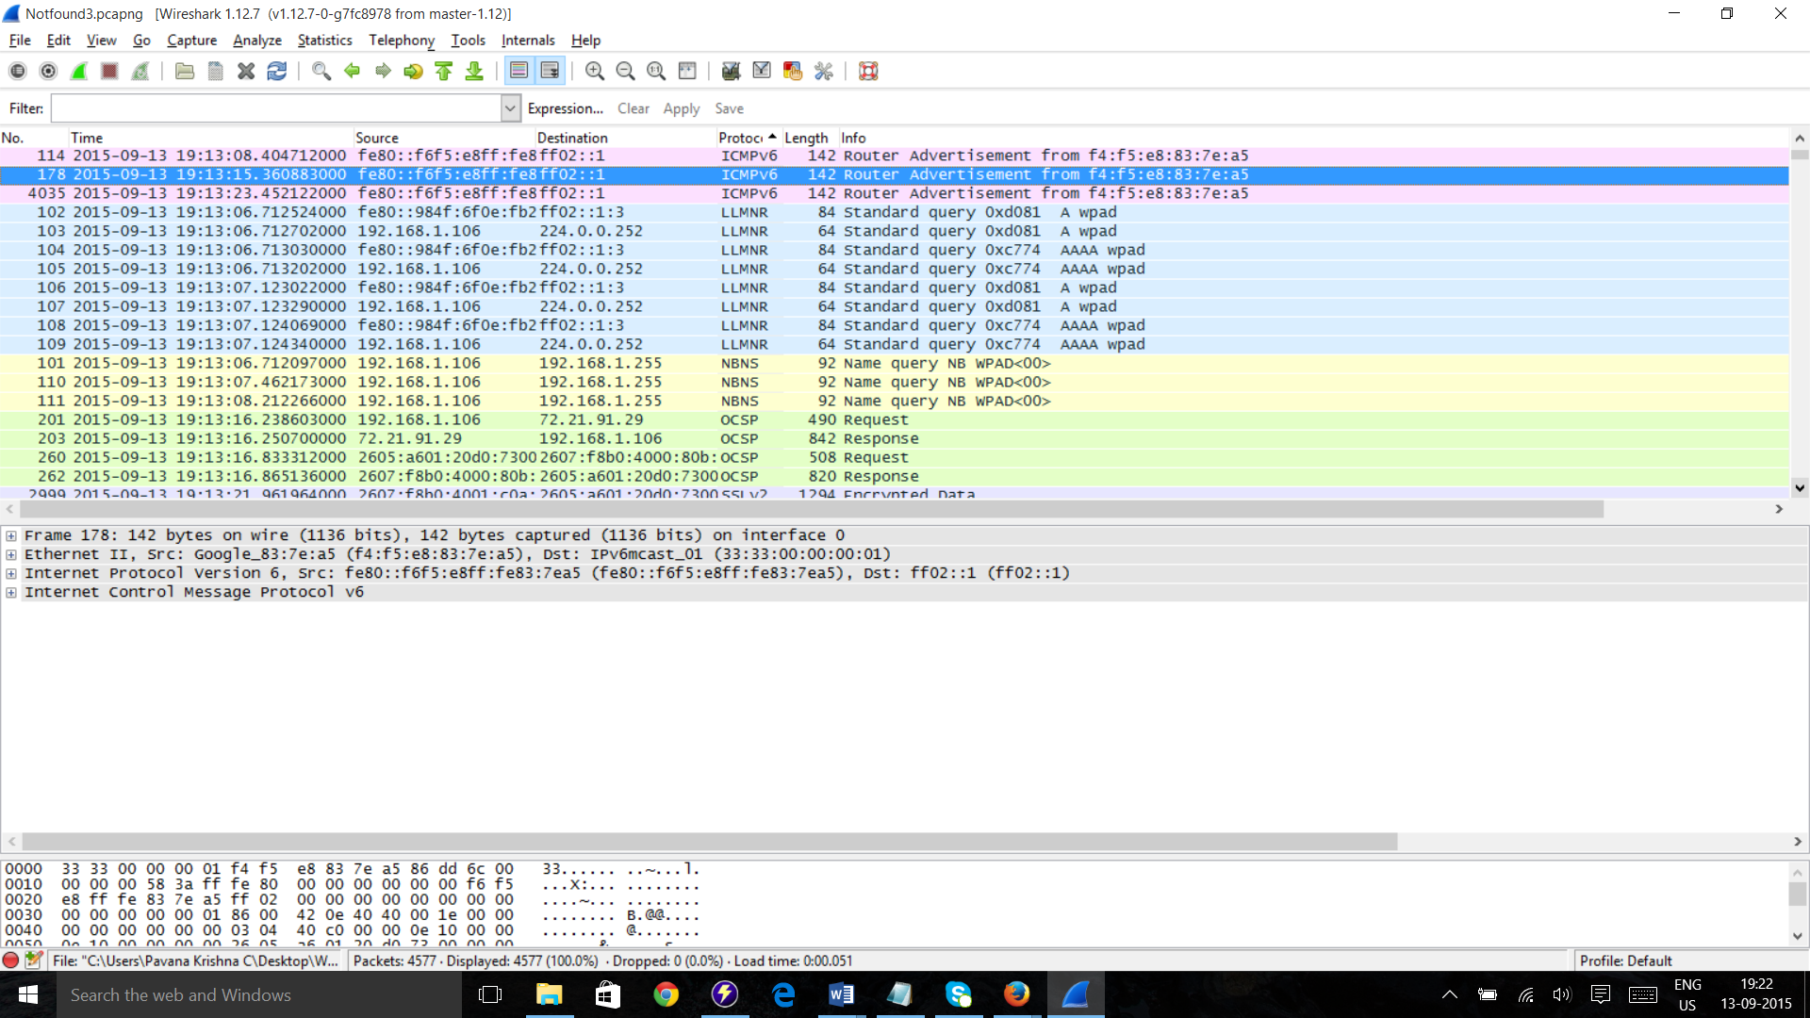

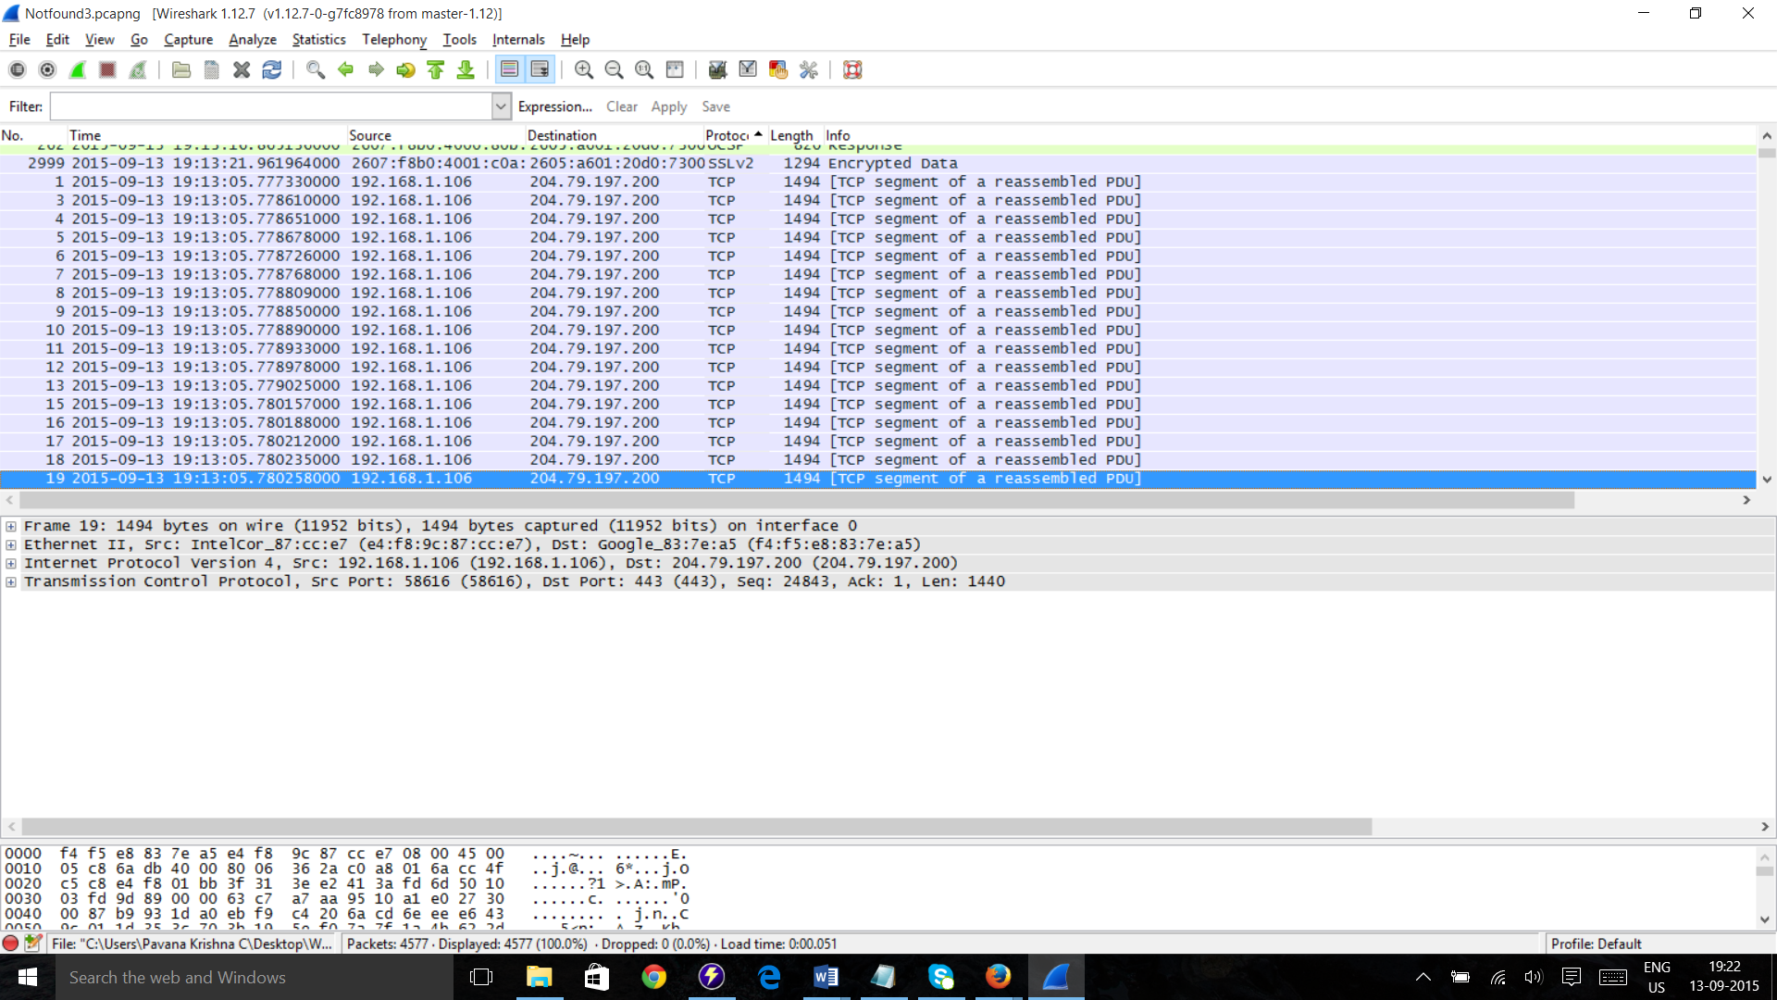

1. HTTP Get Message was sent on 09-13-2015 19:13:18.5229620000 and

HTTP Ok Message was received on 09-13-2015 19:13:18.5730890000

So the time difference between the two messages is 0.050127 seconds

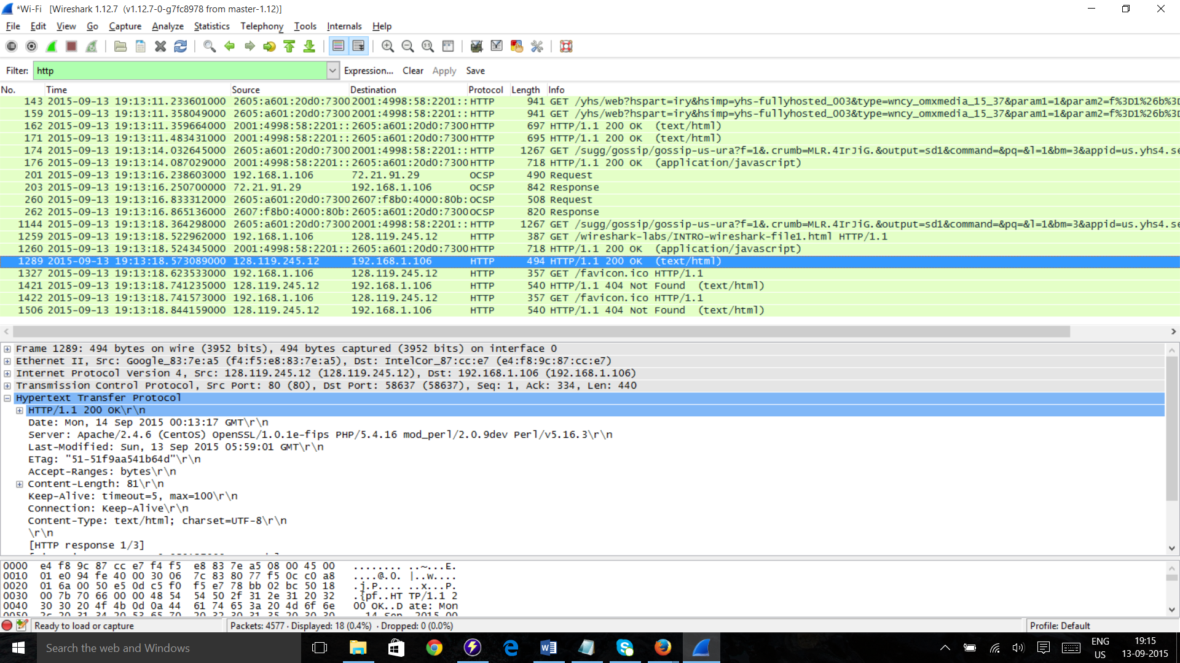

1. The Internet Address of the gaia.cs.umass.edu is 128.119.245.12 &

The Internet Address of my Computer is 192.168.1.106 as mentioned in the above screenshot.

1. The Printed Files of Get and Ok Messages are attached below.

 